**Proposal of a Fossil-Free Union**

Adrien Fabre, 2024

**There is strong demand for a *global* climate policy.**

* The African Union recently adopted the [Nairobi declaration](https://media.africaclimatesummit.org/NAIROBI+Declaration+FURTHER+edited+060923+EN+920AM.pdf) calling for a global carbon taxation regime, a proposal immediately [supported](https://x.com/vonderleyen/status/1700416700238225659) by EU Commission President Ursula von der Leyen.
* Surveys in the G20 countries show that the global level is the most popular for implementing climate policy. They also reveal massive support (over 80%) for capping CO2 emissions, and a consensus to distribute the rights to pollute equally to every human.
* Carbon trading would bring cost-effectiveness and guarantee that all countries meet their target.

The main principles of the Fossil-Free Union are:

1. **Cap emissions in accordance with the Paris Agreement, using an Emissions Trading Scheme (ETS)**

* The plan would define a carbon budget to be broken down into yearly quotas.
* CO2 emission permits would be auctioned to emitting companies, as in the EU ETS.
* A steadily increasing carbon price floor starting at $5/tCO2 would ensure incentives to decarbonize.
* The higher prices would ultimately be paid by individuals in proportion to their carbon footprint.

1. **Split the revenues among countries based on their carbon budget, adjusted from equal per capita**

* Each country is granted a trajectory of carbon allowances, converging to zero in 2080.
* The benchmark carbon budget for a given country is given by equal rights per capita.
* The benchmark is set as the global carbon budget divided by the initial year (2030) population.
* Given its carbon budget, a country’s allowance *trajectory* is tailored to its emission needs.
* China and the EU are granted allowances corresponding to their own decarbonization pathway.
* Further departures from the benchmark allocation can be agreed by a qualified majority.

|  |  |  |  |  |  |  |  |  |
| --- | --- | --- | --- | --- | --- | --- | --- | --- |
|  | **Africa** | **China** | **Latin America** | **India** | **Europe** | **Other Asia** | ***Union*** | ***World*** |
| **Equal p.c.** | 144 | 134 | 61 | 133 | 49 | 115 | *653* | *754* |
| **Proposal** | 144 | **154** | 61 | 133 | **23** | 115 | *647* | *748* |

Carbon budget over 2030-2080 (in GtCO2): budgets in the proposal and how they compare to equal p.c.

1. **A Fossil-Free Union led by the Global South**

* It could be launched by Brazil, China, EU, and Global South countries.
* It could be launched by a subset of these countries, and would be open to any country.
* As allowances roughly correspond to the union’s emissions needs, the carbon price would be low.
* A carbon tariff would price imports to the union in proportion to their carbon content.

1. **Complement this Plan with other policies for climate and social justice**

* A global wealth tax funding lower-income countries to address historical responsibilities.
* A fair international financial system: debt relief, rechanneling of SDRs, capitalization of MDBs…
* Additional national climate measures are necessary to facilitate decarbonization.

**Each country would find an interest in joining the union**

* Emission allowances exceed Nationally Determined Contributions (NDCs) and long-term targets.
* China and the EU risk missing their targets (especially the EU). The union would guarantee that they meet their target by purchasing allowances at a low cost to the rest of the world.
* China would find a market for its low carbon products.
* LICs (in particular in Africa) would obtain sizable transfers by selling allowances. By forgoing allowances to high emitters like China, LICs would encourage them to join, raising the carbon price. This apparent renouncement from LICs could even lead to additional transfers in their favor.
* Middle-income countries (India, Brazil, Indonesia) would get allowances in line with their needs, encouraging them to decarbonize with the guarantee that the rest of the world also decarbonizes.

**A Plan widely supported by the public in the G20 countries**

* Representative surveys explained a similar plan to respondents (emphasizing its costs) then measured support. 76% in Europe and 54% in the United States support the Plan.
* Different survey experiments confirm that support for global policies is sincere.
* 60% of people prefer a political program that includes a global climate plan to one without.

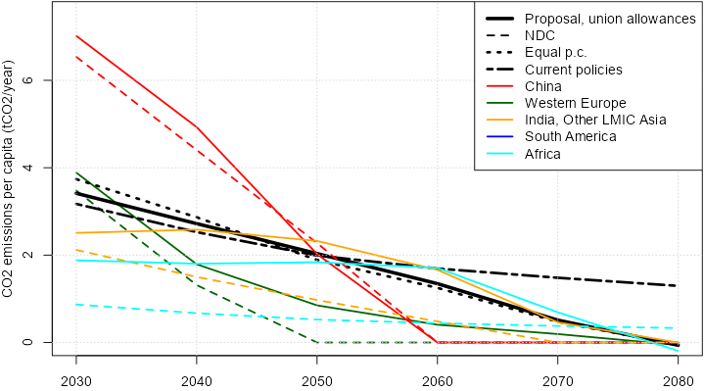

CO2 emissions allowances for selected regions, compared to NDCs (in tCO2 p.c.).   
Source: van de Ven et al. (2023) and author’s computation.

**Bibliography**

* The representative survey : *International Attitudes Toward Global Policies*, Adrien Fabre, Thomas Douenne & Linus Mattauch, 2023. [bit.ly/Fabre2023](https://papers.ssrn.com/sol3/papers.cfm?abstract_id=4448523)